Download Sonar Cube Server from:

<https://www.sonarsource.com/products/sonarqube/downloads/>

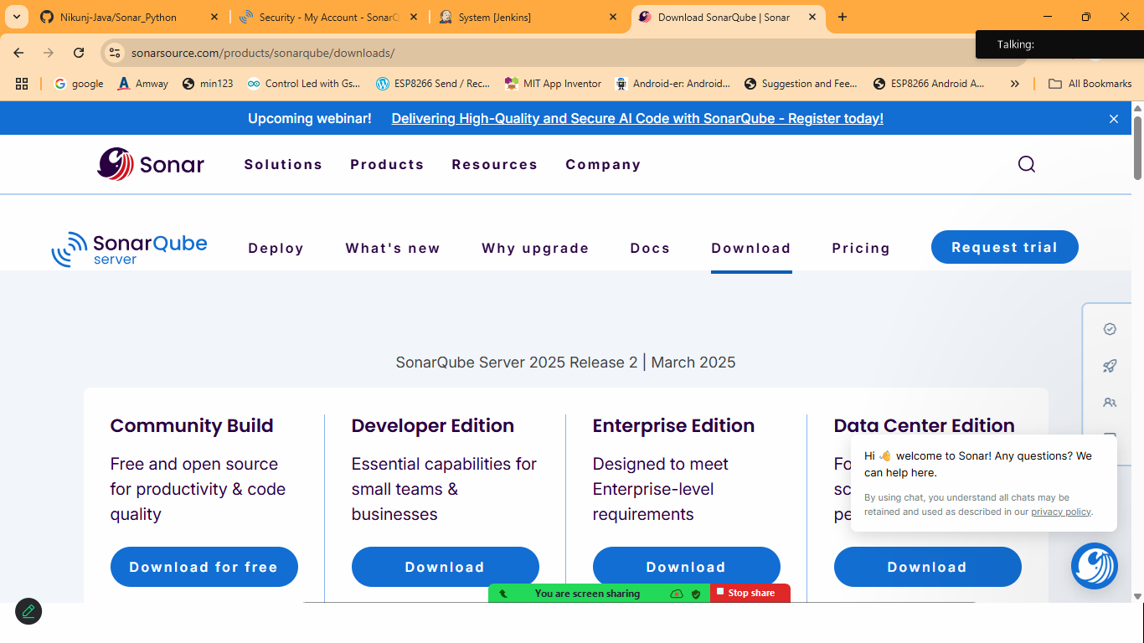

Extract it on C: Drive

Goto> bin>choose your os> Double Click on StartSonar

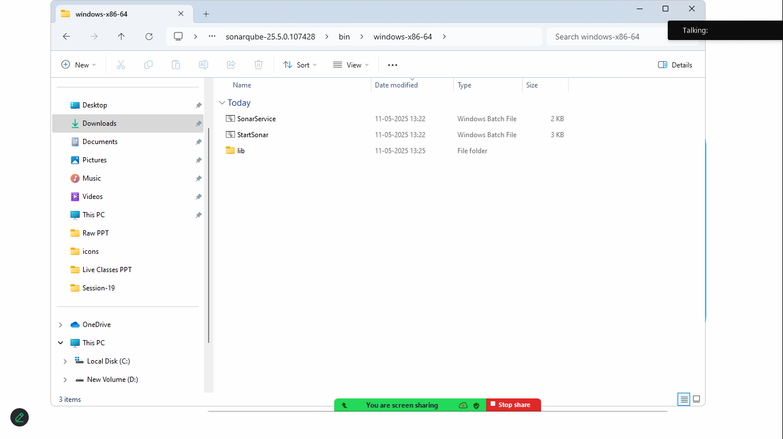

Goto>browser>http://localhost:9000

Make sue: JAVA 17 is installed on Your machine

Use Default username and password :

Username: admin

Password: admin

Now update the password

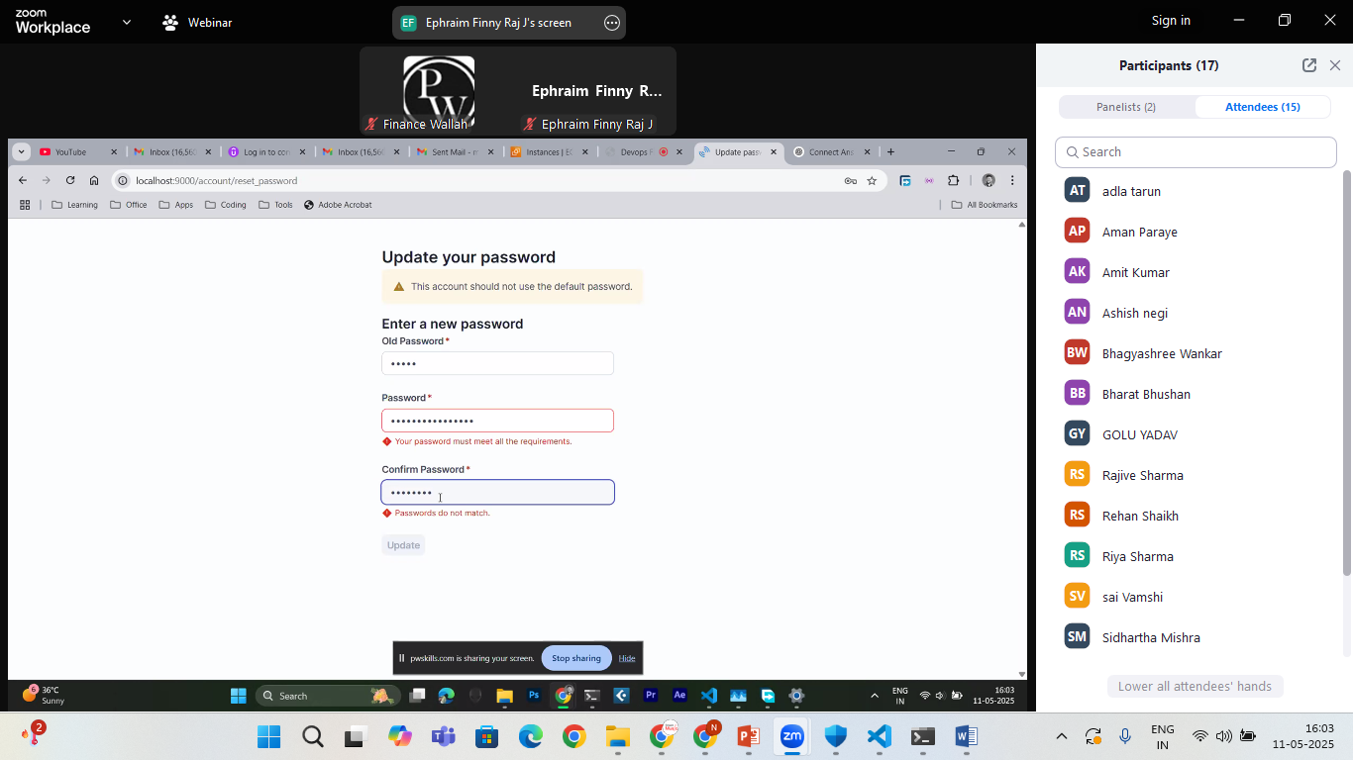

Goto>dashboard

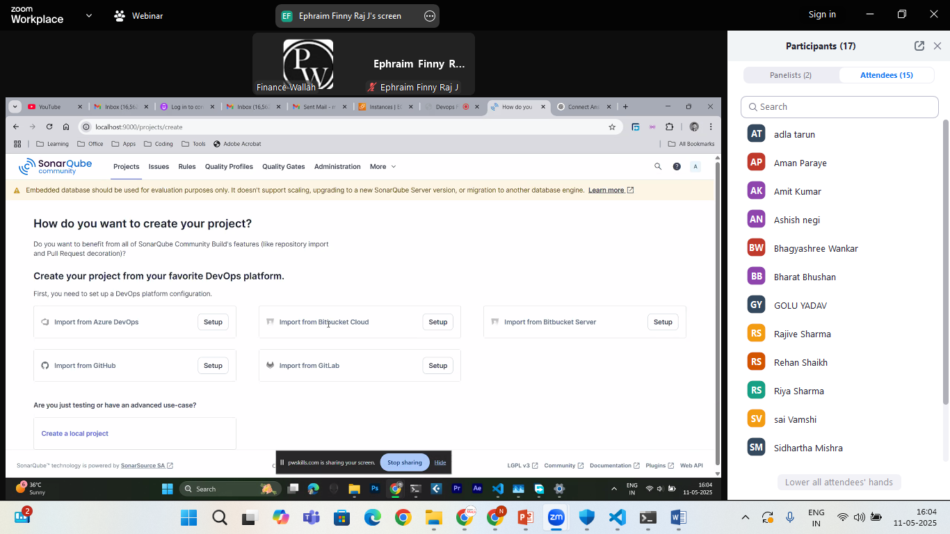

Click on Your Profile>MyAccount>Security

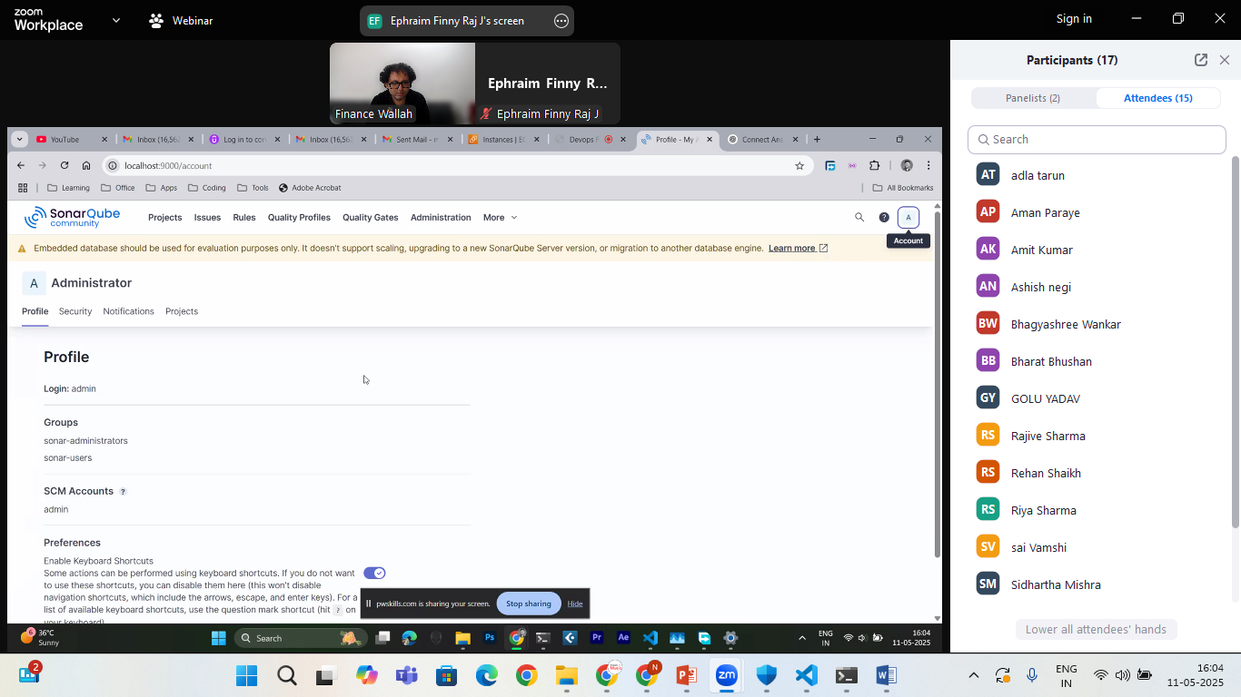

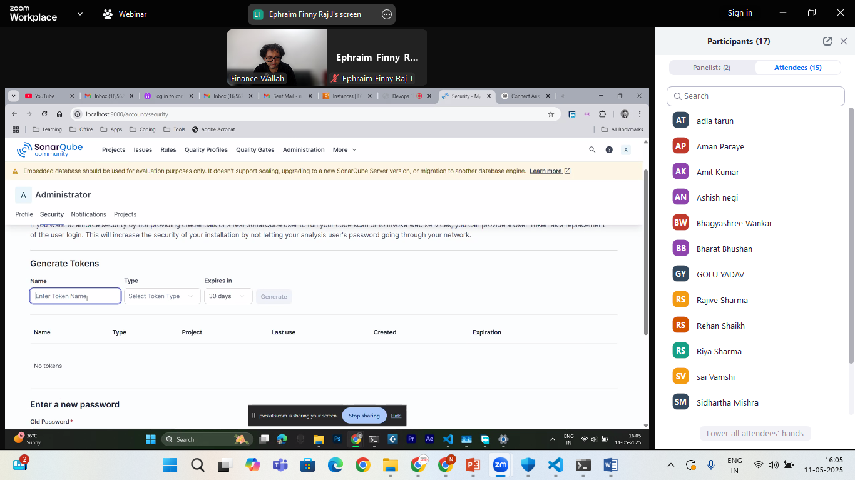

Generate token using by default option and save the token to secure place in txt file

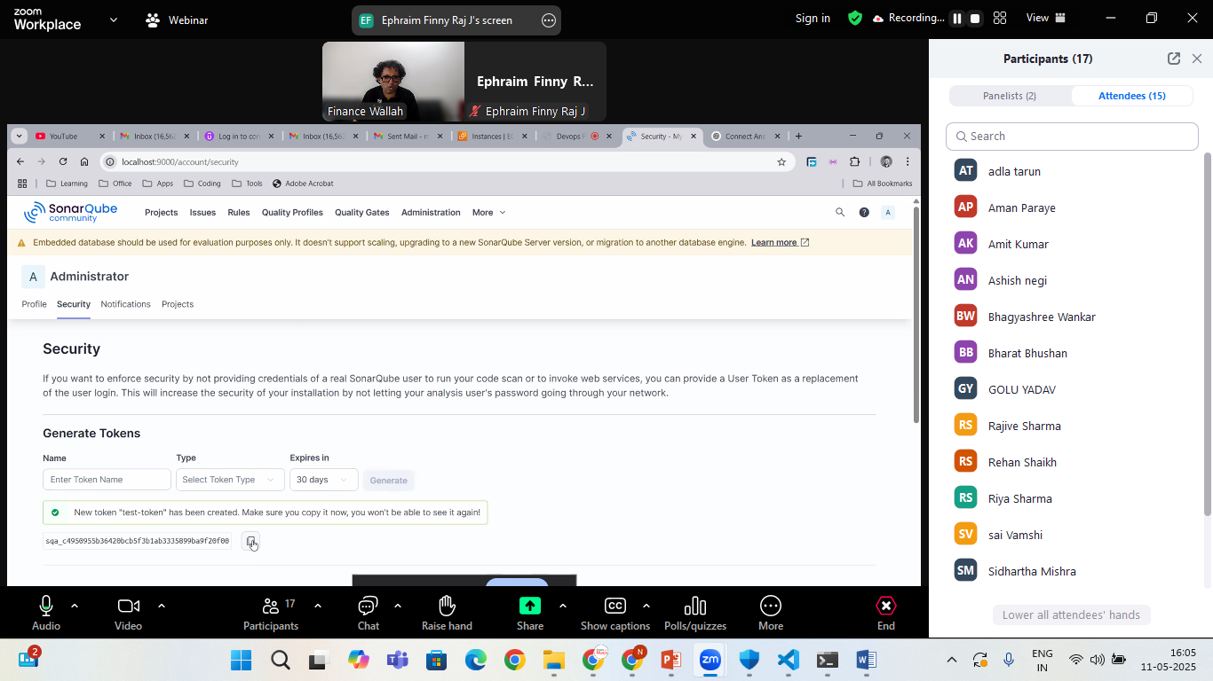

Also download Sonar-scanner in your machine and set the environment path

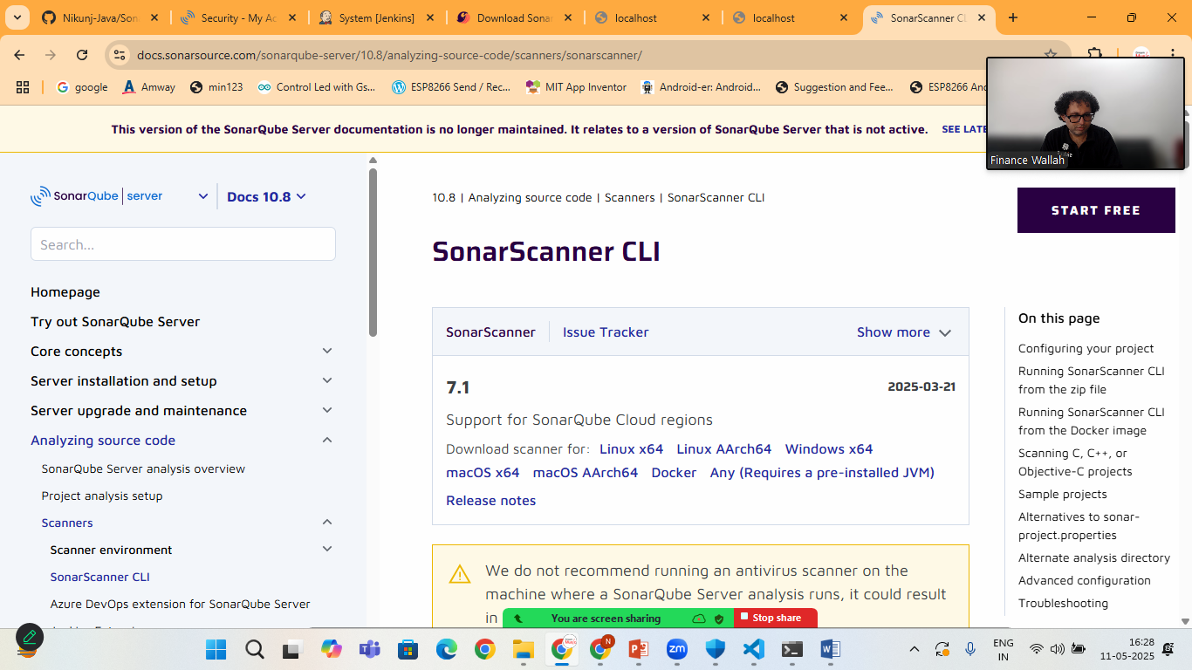

Choose your machine version and download

Copy the path and set it to system path>

**>open start menu> Environment Variable**

**> click New > add path to bin folder,**

**Eg: c:\sonar-scanner\bin**

Extract it and run

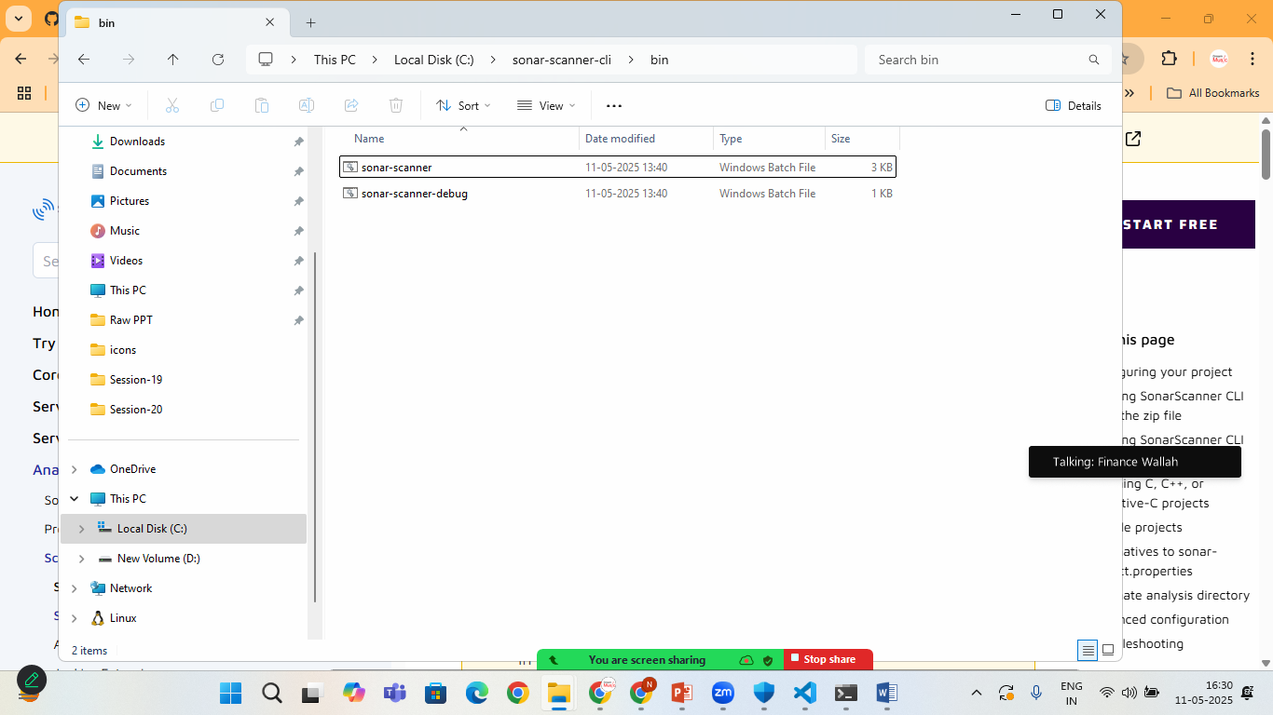

Lets create Python Program and Its Testing

Create project structure like this:

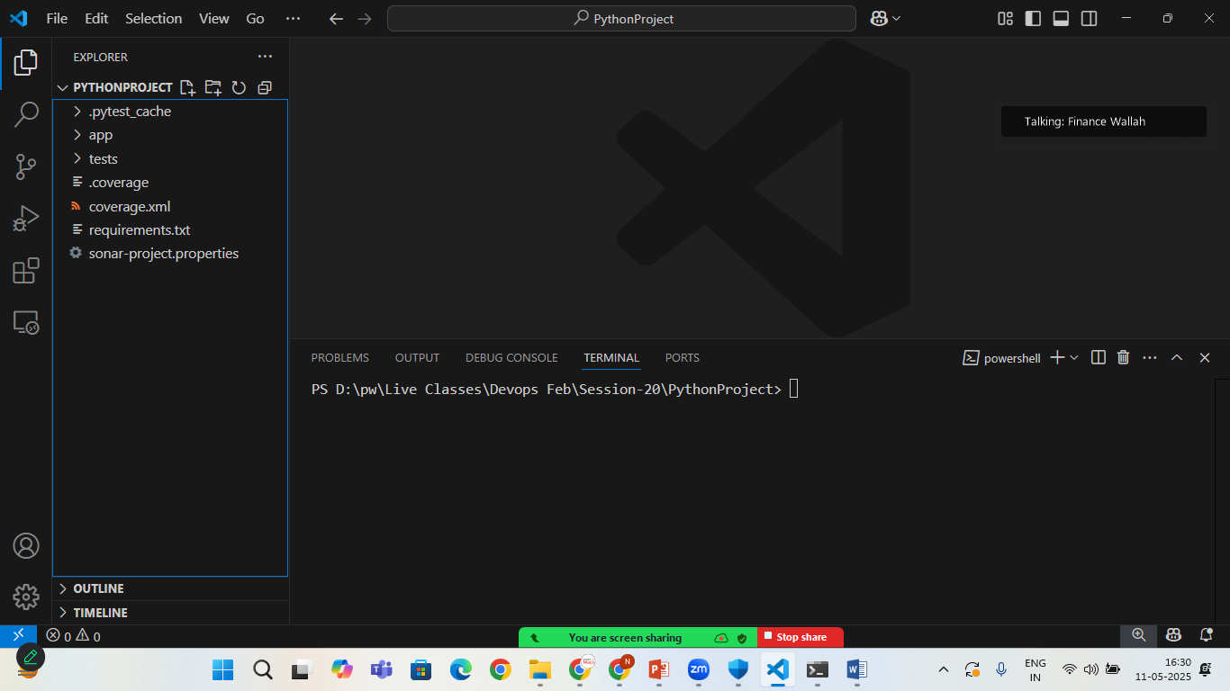

Calculator.py

def add(a,b):

    return a+b

def subtract(a,b):

    return a-b

def divide(a,b):

        if b==0:

            raise ValueError("Cannot devide by zero")

        return a/b

def multiply(a,b):

    return a*b

test_calculator.py

import pytest

from app.calculator import add, subtract, divide, multiply

def test_add():

    assert add(2,3) == 5

def test_subtract():

    assert subtract(10,2) == 8

def test_divide():

    assert divide(20,10) == 2

def test_multiply():

    assert multiply(3,9) == 27

def test_divide_by_zero():

    with pytest.raises(ValueError):

        divide(10,0)

create requirements.txt

pytest

open the terminal and run

* pip install –r requirements.txt
* coverage run –m pytest
* coverage xml

finally run

>sonar-scanner

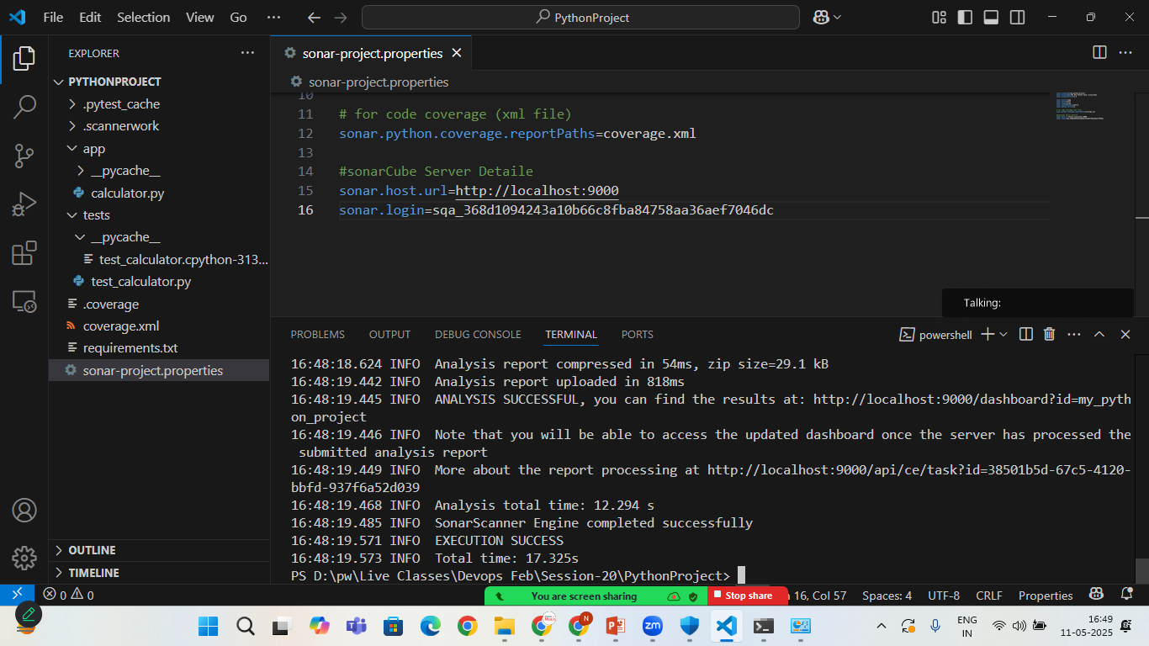

Now> goto>sonarcube>

Localhost:9000

Click on projects

You will see your project is uploaded successfully on sonarcube with all the report and security

